

**NEW ERA UNIVERSITY COLLEGE**

|  |
| --- |
| Faculty of Computer Science & Information Computing Technology |
| Department of Information Computing Technology |

**TNWK 213 NETWORKING**

**GROUP ASSIGNMENT**

**LIM YEE JIE 2290025-DCS**

**ON WU XU 2290113-DCS**

**YAP KAH SENG 22900146-DCS**

**HUAI ZI YAO 2290085-DCS**

**LECTURER: ROZLINDA RADZALI**

**DATE OF SUBMISSION:**

**CONTENTS**

**1.0 Introdction 3**

**1.1 Overview 3**

**1.2 Objective 3**

**1.3 Scope 3**

**2.0 Floor Plan Layout 4**

**2.1 Floor 1 - Classroom 4**

**2.2 Floor 2 – Computer Centre 5**

**2.3 Floor 3 – Staff Office 7**

**2.4 Floor 4 – Multipurpose Hall 9**

**3.0 Network Devices 11**

**3.1 Router 11**

**3.2 Switch 12**

**3.3 Cabling 13**

**4.0 Network Design 14**

**4.1 Floor 1 - Classroom 14**

**4.2 Floor 2 – Computer Centre 15**

**4.3 Floor 3 – Staff Office 16**

**4.4 Floor 4 – Multipurpose Hall 17**

**4.5 Whole Buildings 18**

**5.0 Individual Components 19**

**6.0 Conclusion 20**

**7.0 References 21**

1. **Introduction**

**1.1 Overview**

Our team has been entrusted by New Era University College (NEUC) to present a network design along with its specifications for the upcoming facility expansion. The objective is to establish a computer network environment within the training facility that aligns with the networking requirements of the new building at New Era University College.

**1.2 Objective**

This project's goal is to plan and set up a Local Area Network (LAN) topology that connects the buildings, as well as to set up network devices that will be used across the facility. To demonstrate how the network connects with one another across the buildings' computer centre, classrooms, offices, and multipurpose Hall, a full floor plan of the buildings and an IP addressing system will also be created.

**1.3 Scope**

This project aims to create a long-term network - a Local Area Network (LAN) - for a dedicated training centre and an office building. The network will allow all computers and hardware in the training facility to access the internet and communicate with one another as well as with other devices like projectors and printers. Dynamic routing will be employed in this project because the Local Area Network will mixed wired and Wireless connections. In a scenario with both wired and wireless connections, dynamic routing protocols like OSPF (Open Shortest Path First) or RIP (Routing Information Protocol) could be more suitable. These protocols can adapt to changes in the network, such as devices joining or leaving the network, changes in link quality, and other dynamic factors. They can help ensure efficient routing and provide redundancy, which is important for maintaining connectivity.

**2.0 Floor Plan Layout**

**2.1 Floor 1 – Classroom**

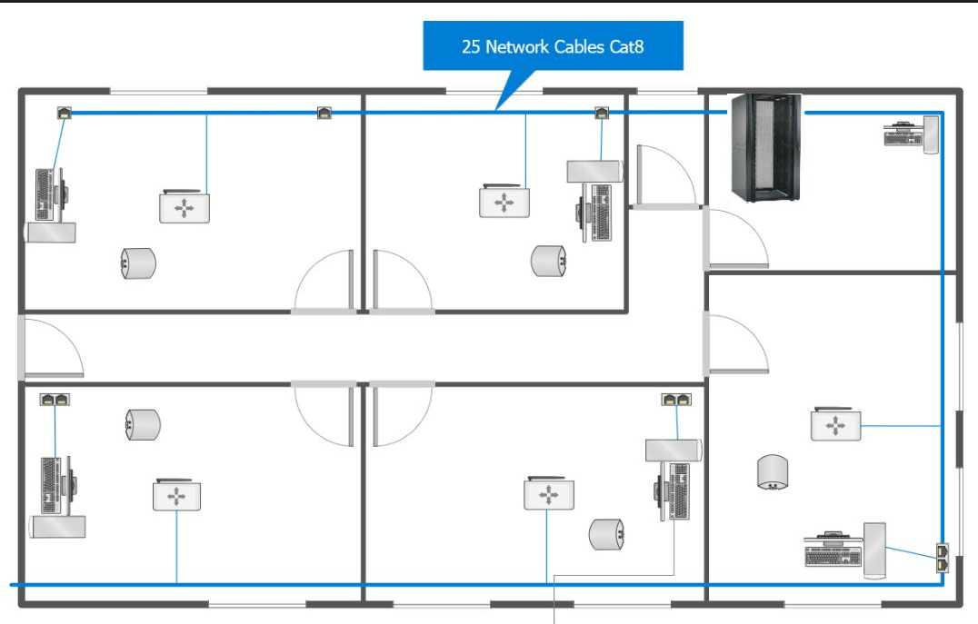

**Server Room**

There's a server there that's responsible for supplying and receiving network traffic for the entire building.

One of the computers, which is not connected to the Internet, is responsible for storing important information.

**Classroom1,2,3,4,5**

The classrooms have same layout and equipe with the following network devices:

A computer with a network interface for the teacher to use in the classroom.

There is a router that allows all students' mobile phones to connect to the network so that they can look up information.

**2.2 Floor 2 - Computer Centre**

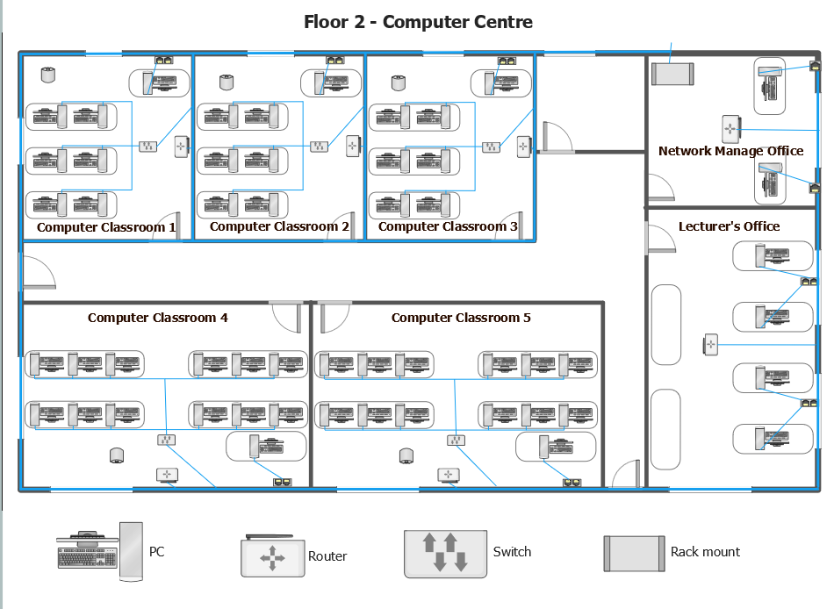

The following details the equipment configuration included in each classroom, as well as the characteristics of the two ancillary offices.

**Computer Classroom 1, 2, 3**

The classrooms equipped with the following network devices:

* 6 PCs for students: providing students with efficient learning tools.
* 1 PC for lecturer: create and edit teaching materials such as courseware, PPT slides, assignments, etc.
* 1 switch: connect student computers together to facilitate internal communications.
* 1 router: provide external network connection for the classroom.
* 1 projector: Display and share teaching materials such as courseware, slides, assignments, etc.

**Computer Classroom 4, 5**

The classrooms have simlar layout with Computer classroom 1,2,3 and equipe with the following network devices:

* 12 PCs for students: providing students with efficient learning tools.
* 1 PC for lecturer: create and edit teaching materials such as courseware, PPT slides, assignments, etc.
* 1 switch: connect student computers together to facilitate internal communications.
* 1 router: provide external network connection for the classroom.
* 1 projector: Display and share teaching materials such as courseware, slides, assignments, etc.

**Network Management Office**

This office focuses on network management and is equipped with the following network devices:

* 1 router: provide network connection for devices in the office.
* 2 PCs: network monitoring, management and troubleshooting.

**Lecturer's Office:**

It's a lecturer's workplace, equipped with the following network devices:

* 1 router: provide stable network access for devices in the office.
* 4 PCs: prepared for lecturers to help them do the teaching materials preparation and other job.

**2.3 Floor 3 - Staff Office**

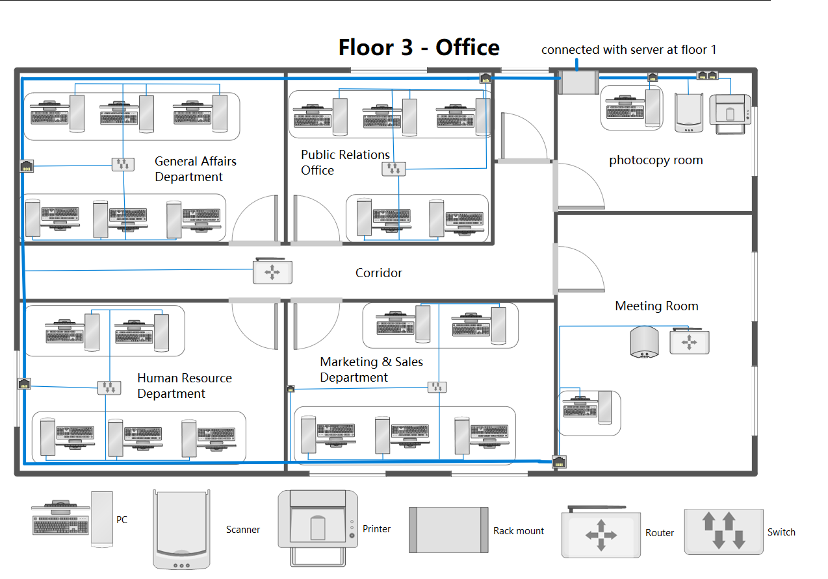

The third floor is primarily responsible for the school's staff offices. There are four main rooms within which are allocated to staff from various departments. In addition to this, there is a photocopy room and a meeting room on the third floor. The layout of each room is described below.

**Staff Offices (x4)**

The four offices on the third floor are for the General Affairs Department, Human Resource Department, Public Relations Office and Marketing & Sales Department. They all have the same layout except for the number of computers.

* PC: Each office is provided with 5-6 PCs which are used as the main office tools of the staff and the network of these computers is provided through a switch connection.
* Switch: Each office will have a LAN port connected to a switch, which is located in the floor of the room, used to connect all the computers in the room to provide a good network environment, the room does not use a Router but a switch because the staff's main office tools are fixed network devices (desktop computers). In addition, Switch has a faster and more stable network environment with multiple devices.

**Meeting Room**

* PC: This room will have a LAN port to connect to a computer that will be used to provide the presenter with a device to control the projector.
* Router: This room will also have a router to provide a good network environment for everyone in the room. The reason for using a Router instead of a Switch in this room is because most people may not be using a fixed device, such as mobile phones, tablets, laptops and other mobile devices. So, using Router can provide a freer and more convenient network environment for these devices.

**Photocopy Room**

The copy room has the following equipment:

* PC: The computer in the copy room is used to control the photocopier and Scanner next to it and is connected to the network through a LAN port.
* Printer: This photocopier is an office tool for the staff and is connected to the network via LAN. So, staff do not have to use the computers provided in the copy room, but can use their own devices to connect.
* Scanner: The Scanner is an office tool that is used in conjunction with the Printer and is also connected to the network via LAN.
* Rack Mount: This Rack Mount connects to the building's server and provides network access to all the devices on this floor.

**Corridor**

Considering that the staff in the four rooms do not just use the computers provided by the school but have other devices such as mobile phones, tablets and laptops. So, we decided to place a Router in the corridor to provide a network environment for the other devices of the staff.

**2.4 Floor 4 – Multipurpose Hall**

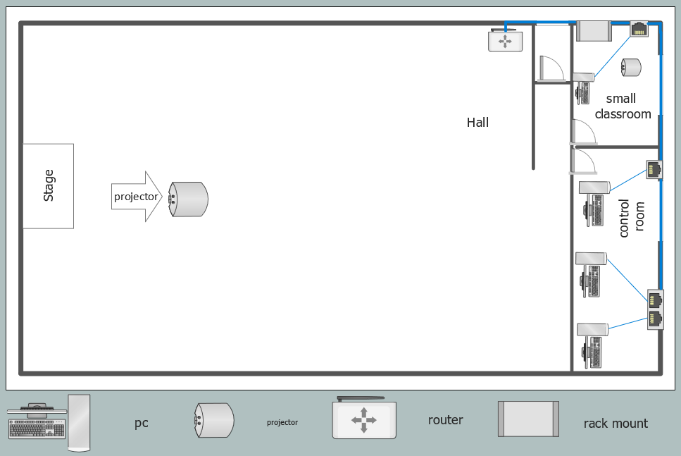

The following show the hall floor. It contains a hall a control room and a small classroom.

**Small classroom**

The classrooms have same layout and equipe with the following network devices:

* 1 PC for lecturer: create and edit teaching materials such as courseware, PPT slides, assignments, etc.
* 1 projector: Display and share teaching materials such as courseware, slides, assignments, etc.

**Hall**

The hall layout and equipe with the following network devices:

* 1 projector: Display and share teaching materials such as courseware, slides, assignments, etc.
* 1 router: provide external network connection for the classroom.

**Control room**

The Control room layout and equipe with the following network devices:

* 3 PC for worker: control the projector, speakers, lights and more in the hall.

**3.0 Network Devices**

**3.1 Router**

* The reason we install a router is to enable multiple devices to share the network.
* The wireless router also has a wireless Wi-Fi network that we use with our laptops, mobile phones, and tablets that can connect to the wireless network to access the internet.
* When we are designing the network layout of a new construction building, we usually consider the amount of foot traffic in this environment to decide how to install a Router.
* For example, a Router will be placed in each classroom because each classroom has a high amount of foot traffic, but in the Office on the third floor, we will install the Router in the corridor to provide a wireless network environment for the four offices, because the there is not a lot of foot traffic in the offices.
* In addition, a Router is placed in the Multipurpose Hall on the fourth floor to provide a wireless network environment for the surrounding classroom, control room and stage areas.

**3.2 Switch**

|  |  |
| --- | --- |
| Product Name | WS-C2960-24TT-L |
| Backplane Capacity | 16Gbps |
| Throughput | 6.5mpps |
| Ports Quantity | 24 |
| Gigabit Ports | 0 |
| Wireless Wired | wired |
| Price | RM931 |

The Cisco WS-C2960-24TT-L switch provides a dependable networking solution equipped with essential features and scalability for schooling environment. Fitting with Cisco's reputation for reliability, the switch ensures stable Internet connection crucial for carrying out uninterrupted educational activities. As the school network expands, the switch's scalability accommodates growth seamlessly. Overall, the Cisco WS-C2960-24TT-L brings reliable and long-lasting utility to the table, aligning well with the needs of a dynamic school setting, and enhancing the overall educational experience.

**3.3 Cabling**

|  |  |
| --- | --- |
| Product Name | Cat 8 |
| Price | RM12.69 per m |

We use CAT 8 cables because CAT 8 networks are faster and more stable. In the long run, CAT 8 lasts longer. Plus, Cat 8 has tighter length restrictions, with an absolute maximum range of only 98 feet for a single cable.Top of Form

**4.0 Network Design**

**Floor 1 – Classroom**

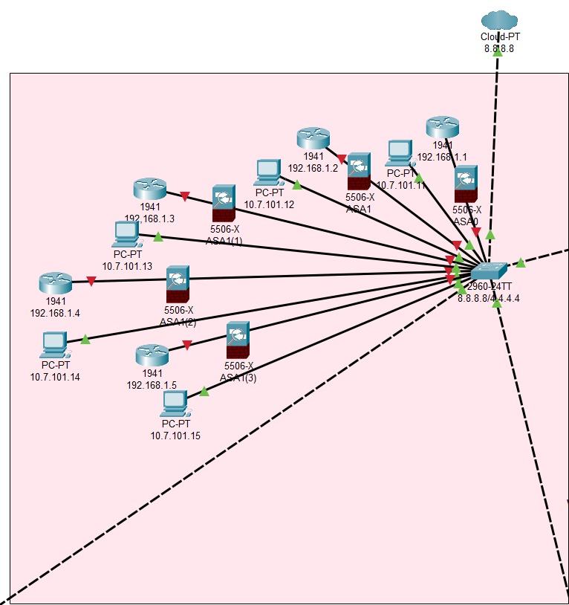

**Floor 2 – Computer Centre**

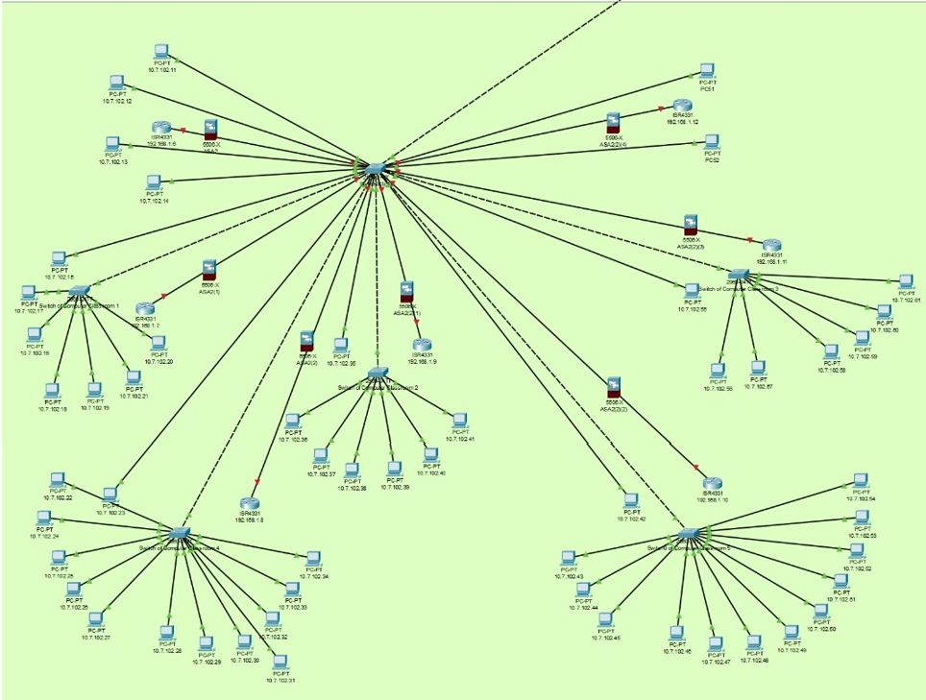

**Floor 3 – Staff Office**

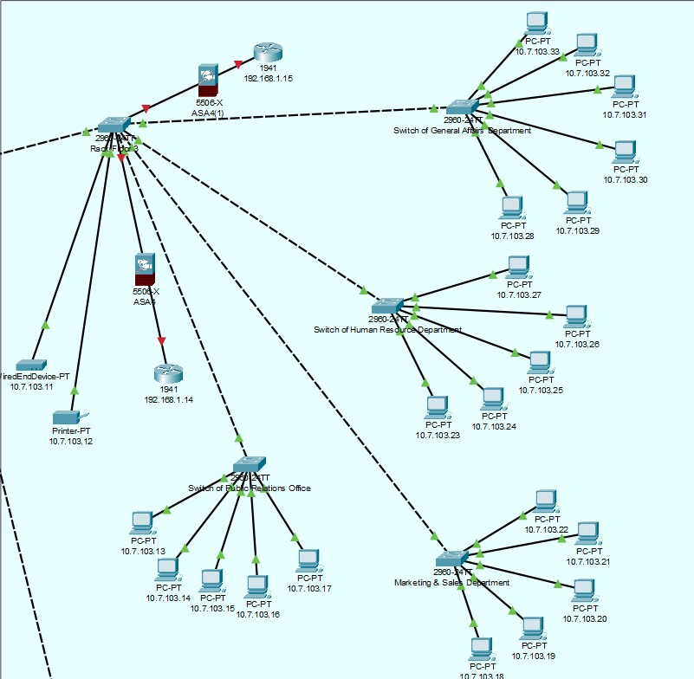

**Floor 4 – Multipurpose Hall**

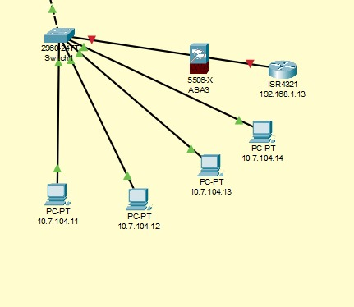

**Whole Building**

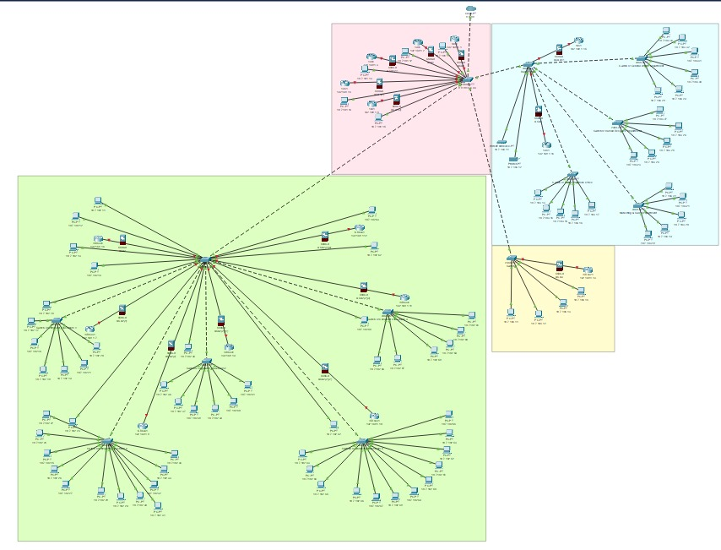

**5.0 Individual Components**

|  |  |  |
| --- | --- | --- |
| **No.** | **Task** | **Executor Name** |
| 1 | 1.0 Introduction | Lim Yee Jie |
| 2 | 1.1 Overview | Lim Yee Jie |
| 3 | 1.2 Objective | Lim Yee Jie |
| 4 | 1.3 Scope | Lim Yee Jie |
| 5 | 2.0 Floor Plan Layout | All members |
| 6 | 2.1 Floor 1 – Classroom | Huai Zi Yao |
| 7 | 2.2 Floor 2 – Computer Centre | On Wu Xu |
| 8 | 2.3 Floor 3 – Staff Office | Lim Yee Jie |
| 9 | 2.4 Floor 4 – Multipurpose Hall | Yap Kah Seng |
| 10 | 3.0 Network Devices | All members |
| 11 | 3.1 Router | Lim Yee Jie |
| 12 | 3.2 Switch | Yap Kah Seng |
| 13 | 3.3 Cabling | Huai Zi Yao |
| 14 | 4.0 Network Design | All members |
| 15 | 4.1 Floor 1 – Classroom | Huai Zi Yao |
| 16 | 4.2 Floor 2 – Computer Centre | On Wu Xu |
| 17 | 4.3 Floor 3 – Staff Office | Lim Yee Jie |
| 18 | 4.4 Floor 4 – Multipurpose Hall | Yap Kah Seng |
| 19 | 4.5 Whole Buildings | All members |
| 20 | Addding IP Address to each devices | Huai Zi Yao |
| 21 | 5.0 Individual Components | On Wu Xu |
| 22 | 6.0 Conclusion | Yap Kah Seng |
| 23 | 7.0 References | Lim Yee Jie |
| 24 | Report Content Collector | On Wu Xu |
| 25 | Report Content Provider | All Members |
| 26 | Power Point Maker | Yap Kah Seng |

**6.0 Conclusion**

The implementation of a comprehensive school network spanning four floors heralds a new era of educational advancement and administrative efficiency. This interconnected network serves as a conduit for seamless communication and collaboration among students, teachers, and staff, transcending physical boundaries.

The network boasts specialized computer classrooms, each equipped with switches and routers that ensure smooth connectivity among computers. This setup empowers students to engage in collaborative projects and access digital resources with ease. The integration of projectors further enriches the learning experience, enabling educators to employ multimedia elements that cater to diverse learning preferences.

A pivotal aspect of the network is the server room, a central hub for data storage, management, and distribution. Real-time attendance tracking streamlines administrative tasks, enhancing accuracy and reporting. The lecturers' offices, furnished with routers and computers, facilitate lesson planning, content creation, and student engagement.

By embracing this network, the school showcases a commitment to preparing students for a digital future. Beyond technological proficiency, the network fosters an environment that nurtures intellectual curiosity and holistic development. This comprehensive approach aligns with the evolving educational landscape, empowering students and educators alike to thrive in a digital age.

In summary, the implementation of the school network transcends conventional boundaries, fostering collaboration, innovation, and growth. It amplifies learning opportunities, enhances administrative processes, and reflects the school's dedication to cultivating a dynamic and forward-looking educational ecosystem.

**7.0 References**

* https://www.netacad.com/zh-hans/courses/packet-tracer
* https://www.conceptdraw.com/solution-park/computer-networks-layout-floor-plans
* https://www.youtube.com/watch?v=oxePXfLvozs&ab_channel=CSOdessa
* https://www.kaspersky.com/resource-center/definitions/what-is-an-ip-address
* https://www.computernetworkingnotes.com/networking-tutorials/ip-address-network-address-and-host-address-explained.html
* https://www.computerhope.com/jargon/r/rackmoun.htm
* https://www.trentonsystems.com/blog/what-is-a-lan-port
* https://www.cloudflare.com/learning/network-layer/what-is-a-network-switch/
* https://blog.tripplite.com/what-is-cat8-cable